**EXPERIMENT 1: BUCK, BOOST, BUCK-BOOST CONVERTER**

**Name: Mansi Uniyal**

**Roll number: 19EE10039**

____________________________________________________________________________

PART A: BOOST CONVERTER

I)

● Vin=24V

● L = 115μH

● C = 54μF

● RL = 11.52Ω

● Switching Frequency(FS) = 50 kHz

● Duty Cycle (D) = 0.5

● MOSFET and diode resistance: 1μΩ

● Diode voltage drop as 0.

● Duty ratio is varied in range 0.1 to 0.9 in steps of 0.1

Case 1: Ideal Case

parasitic resistance of inductor rl = 0

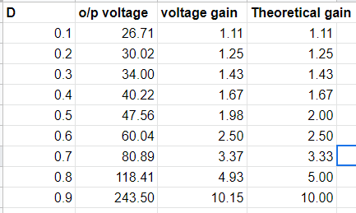

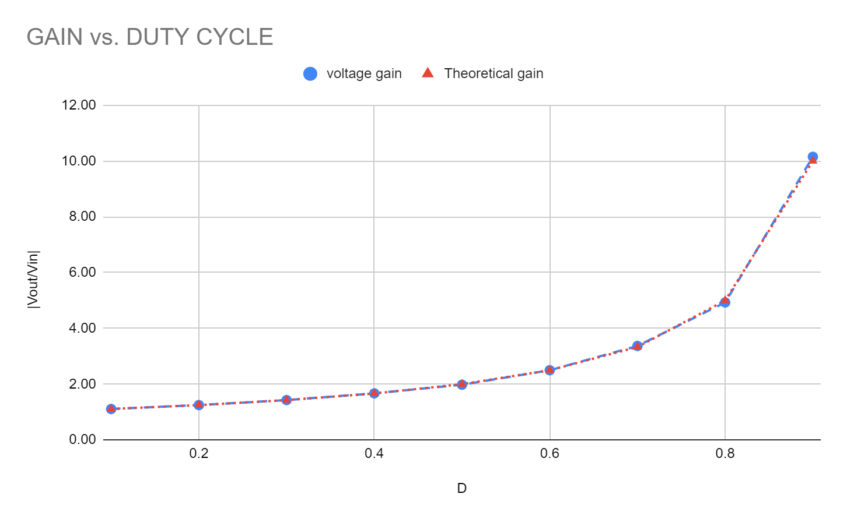

The graph shows that the experimental and theoretical values follow the gain of the boost converter i.e. Gain = 1/(1-D). The curve is exponential and increases with the duty cycle ratio.

Case 2: Practical Case

parasitic resistance of inductor rl = 5% of RL

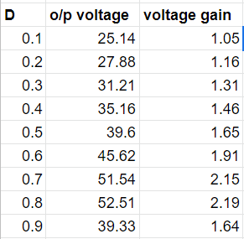

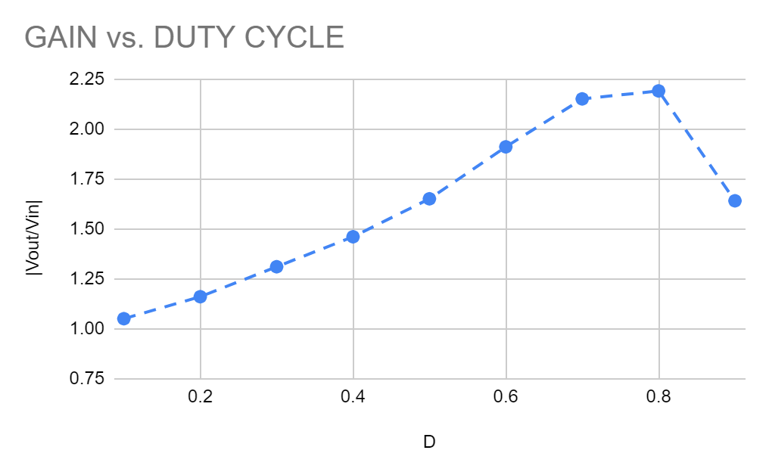

There is power dissipation in practical cases because of parasitic inductance. Hence it’s not exactly a rising exponential curve. For a very high value of duty ratio, gain decreases as more power gets dissipated.

II)

D=0.5;

RMS Capacitor Current: 4.34 amp

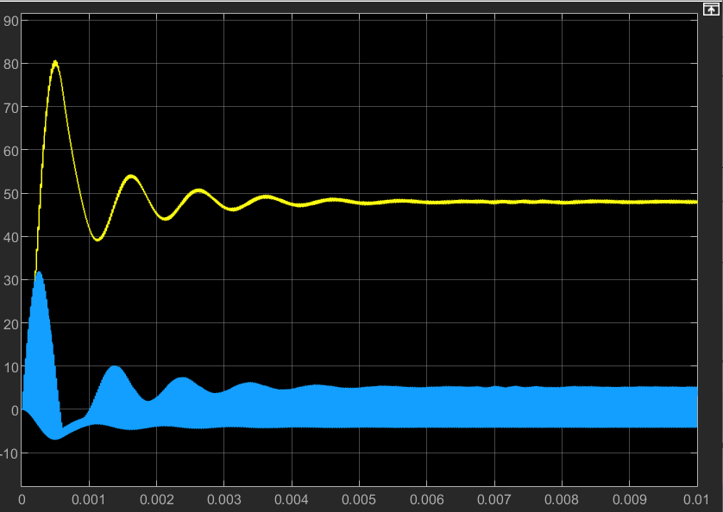

III)

For practical case: When rl = 5% RL, the inductance for which converter falls under CCM mode.

D=0.5;

Inductance = 14.4 uF

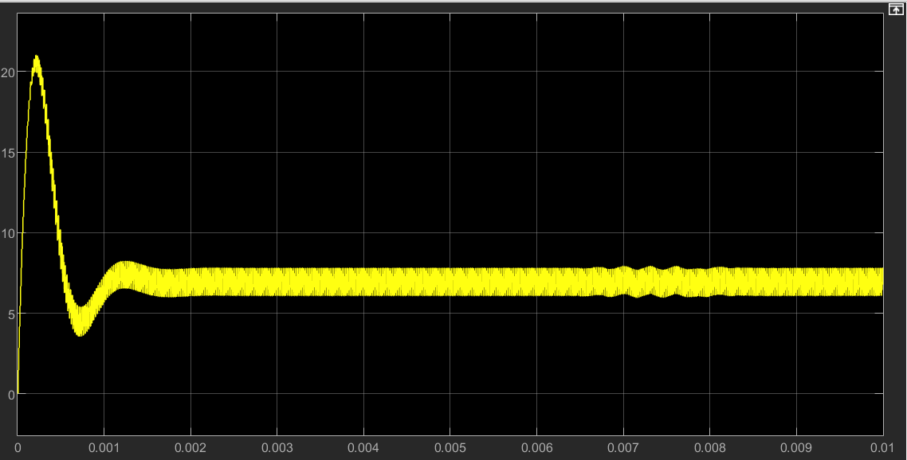

IV)

For the ideal case with D=0.5, Initial output voltage = 0 V, Inductor current, and output voltage builds up from starting to steady-state.

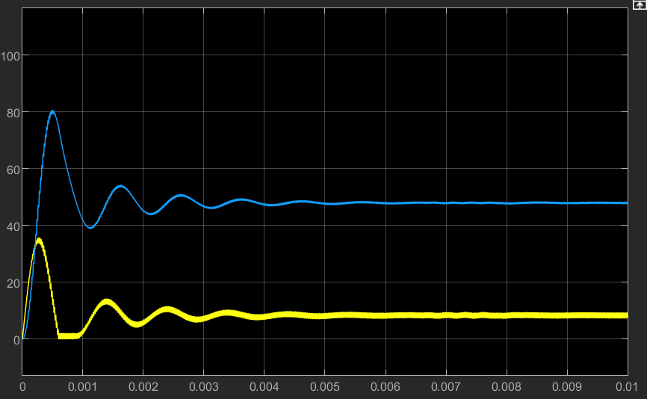

Capacitor Current, Inductor Voltage

Transient Current

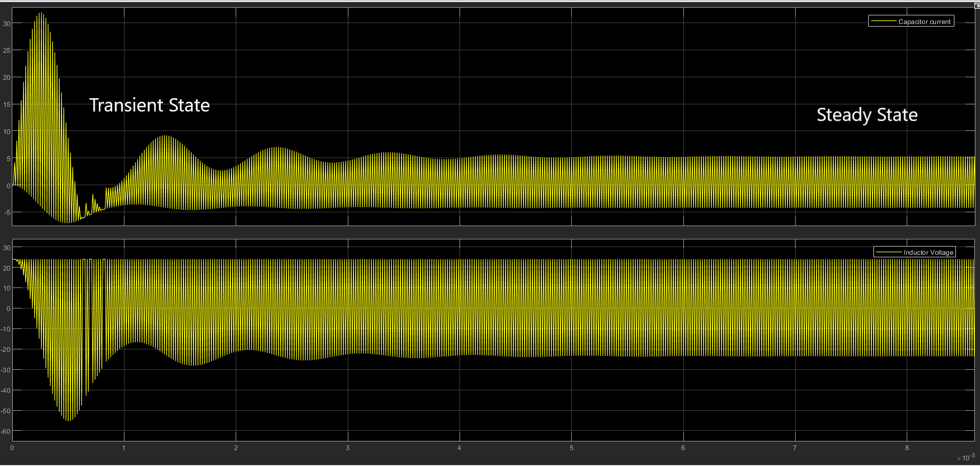

V)

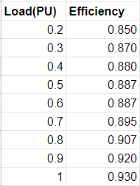

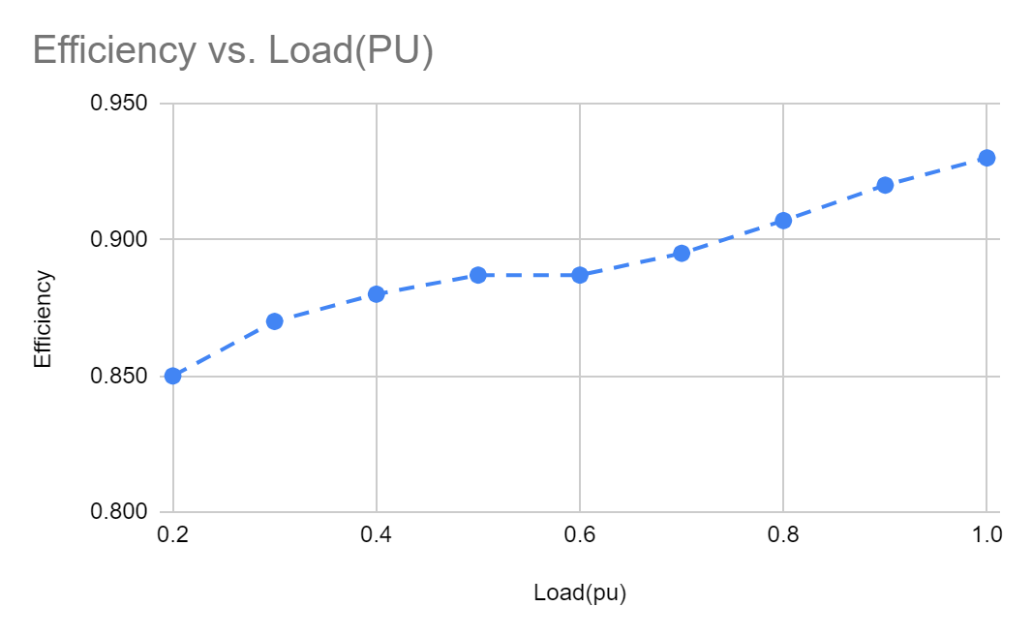

____________________________________________________________________________

PART B: BUCK-BOOST CONVERTER

I)

● Vin=57V

● L = 226μH

● C = 54μF

● RL = 11.52Ω

● Switching Frequency(Fs) = 50 kHz

● Duty Cycle = 0.5

● MOSFET and diode resistance: 1μΩ

● Diode voltage drop: 0

Case 1: Ideal Case

parasitic resistance of inductor rl = 0

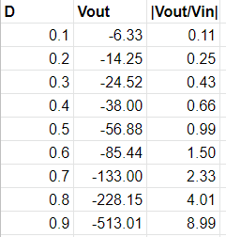

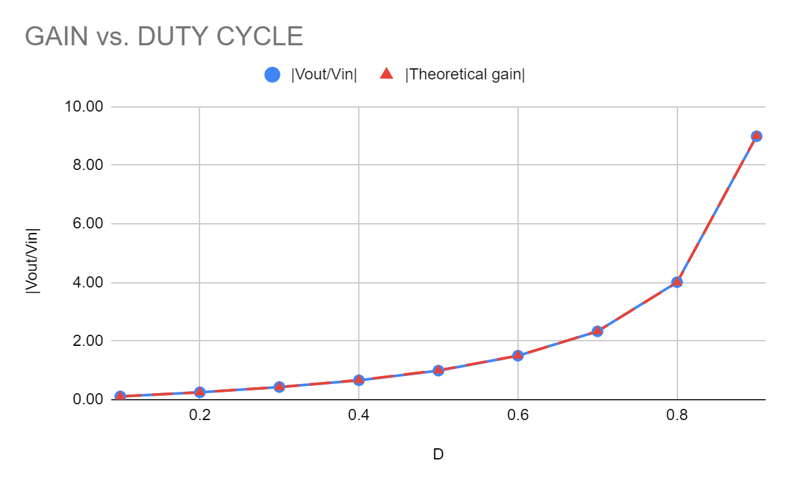

For the ideal case, the graph is again exponentially increasing, and much similar to theoretical value according to the gain formula Gain = - D/(1-D), in CCM condition

Case 2:

parasitic resistance of inductor rl = 5% of RL

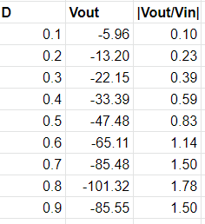

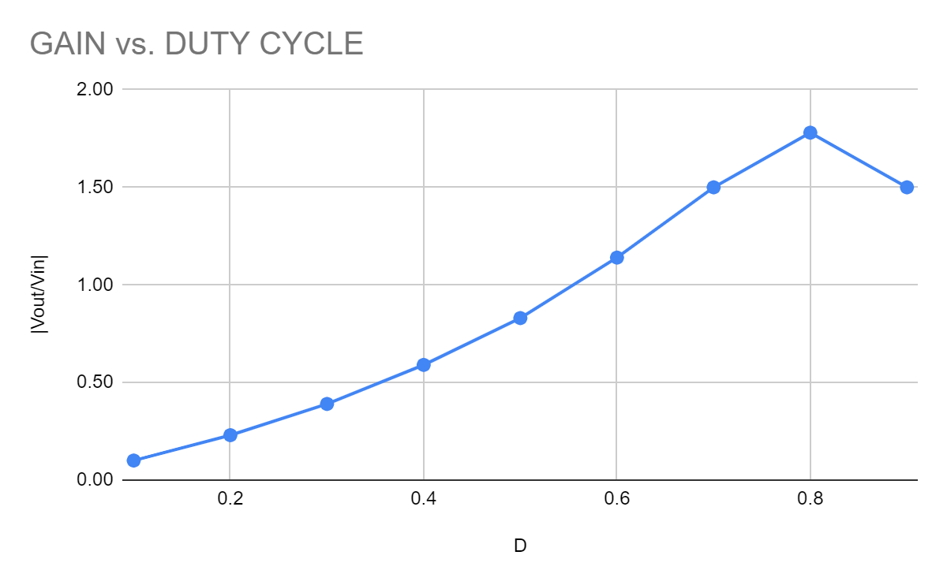

For the practical cases where there is parasitic resistance with the inductor, hence there is power dissipation. With a high duty ratio, there is a greater power loss and gain decreases. Here, 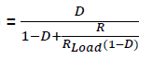

II)

IDEAL CASE

D=0.457 Fsw for which system in CCM and DCM

Experimentally, Fs = 7.55 KHz

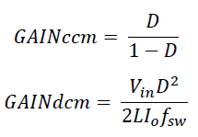

In Limiting condition at both, the gains will be the same

So theoretically DCM to CCM transition happens at Fs=7.515KHz for no parasitic resistance

Negative values of IL signifies DCM and positive values as CCM.

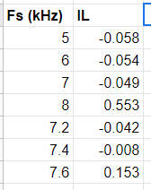

PRACTICAL CASE

D=0.457 Fsw for which system in CCM and DCM

Experimentally, Fsw = 7.95 KHz

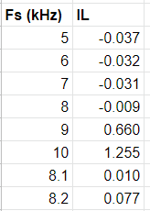

III)

IDEAL CASE:

Vin = 57V

C = 54μF

RL = 11.52Ω

Fs = 50kHz

L=226μH

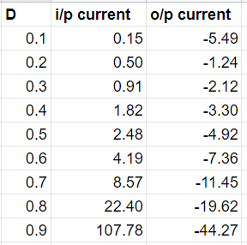

____________________________________________________________________________

PART C:

(a): Voltage stress of Switch. Both are almost the same

Boost converter

Switch voltage stress=105.7V

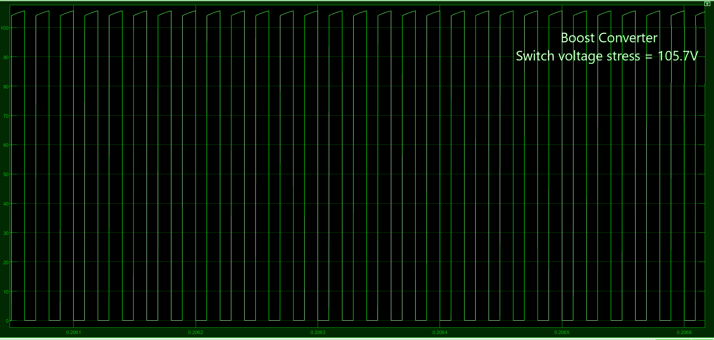

Buck-boost converter

Switch voltage stress=105.3V

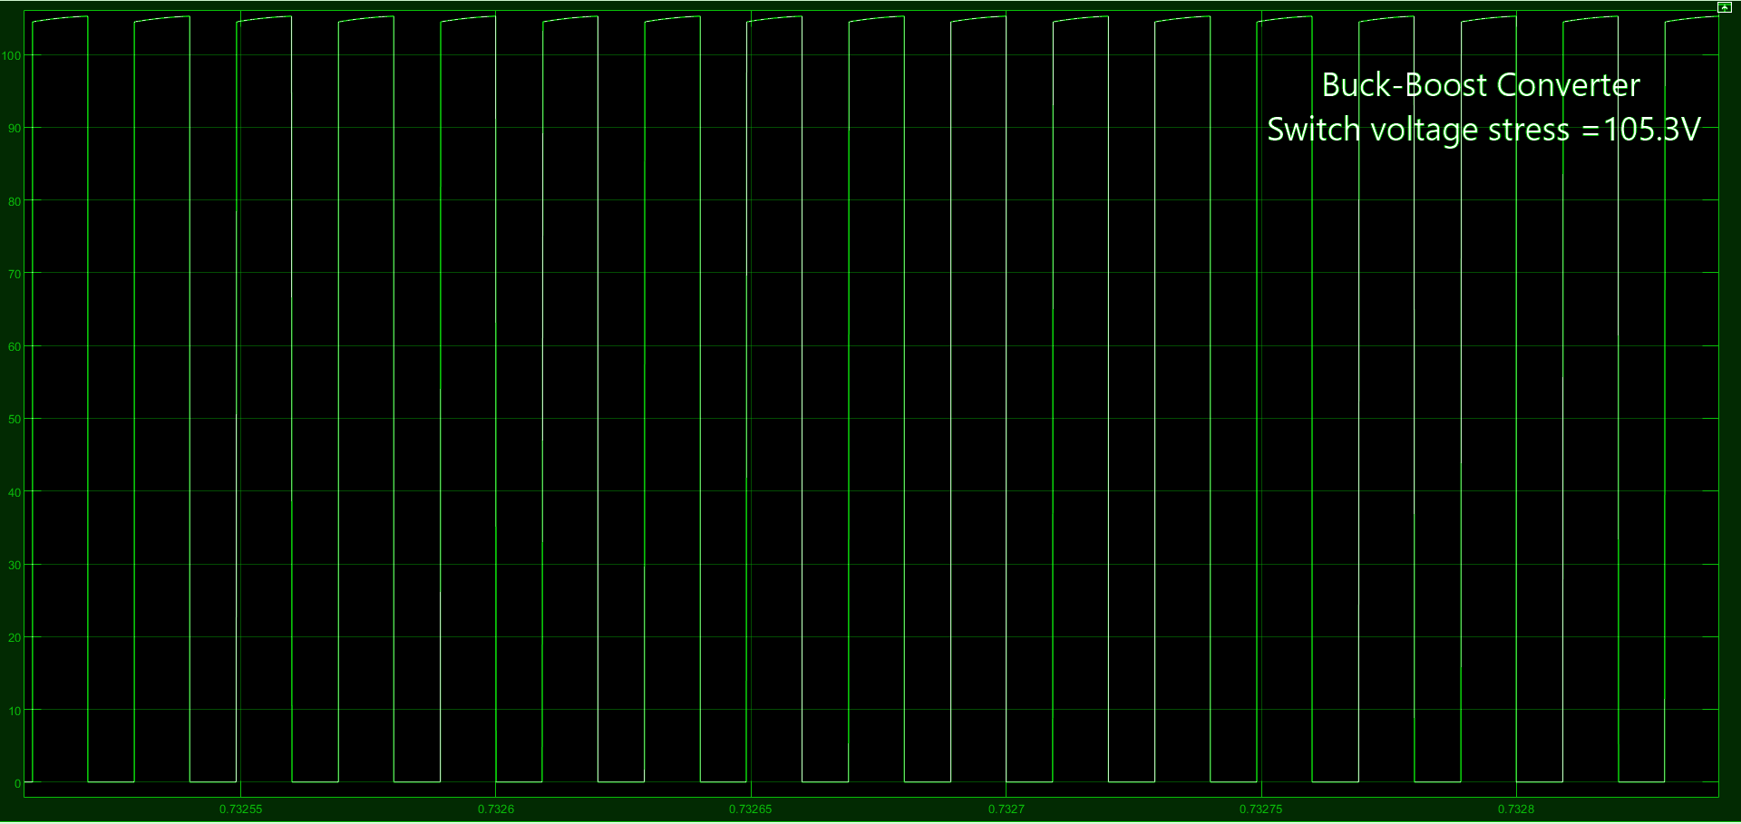

(b): Voltage stress of Diode. Both are almost the same

Boost converter

Diode voltage stress=105.7V

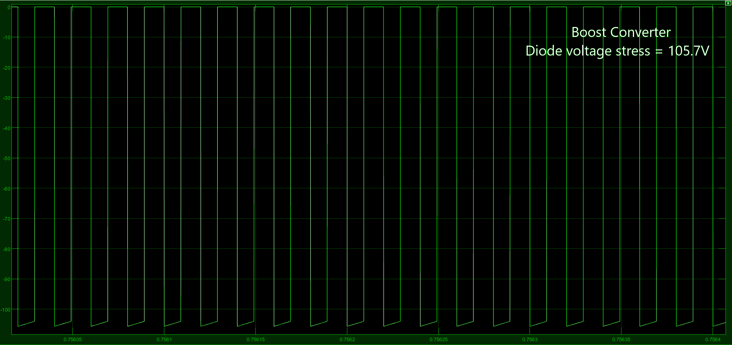

Buck-boost converter

Diode voltage stress=105.3V

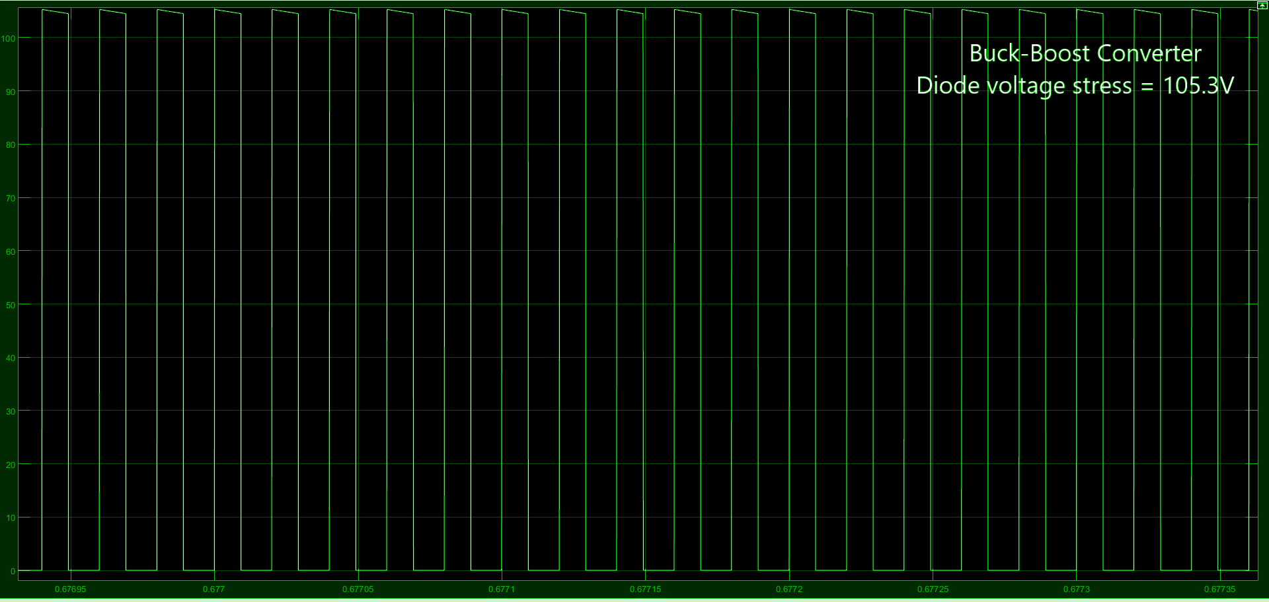

(c): Current stress of Switch. Boost has higher switch current stress.

Boost converter

Switch current stress=19.02A

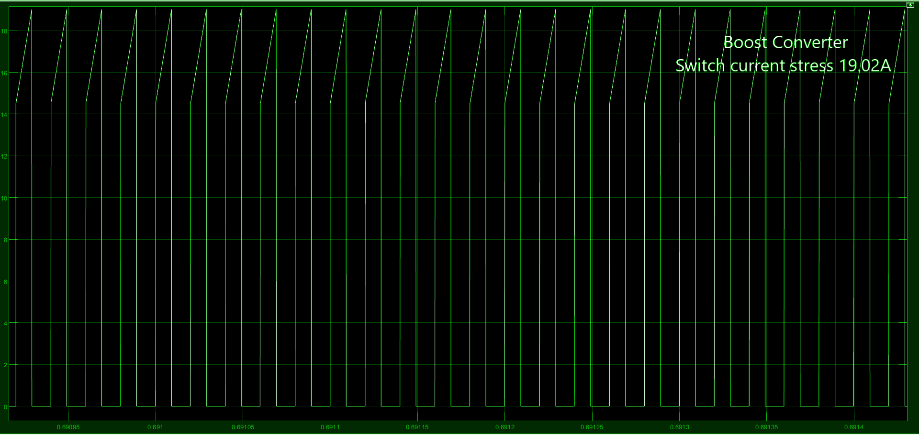

Buck-boost converter

Switch current stress=10.12A

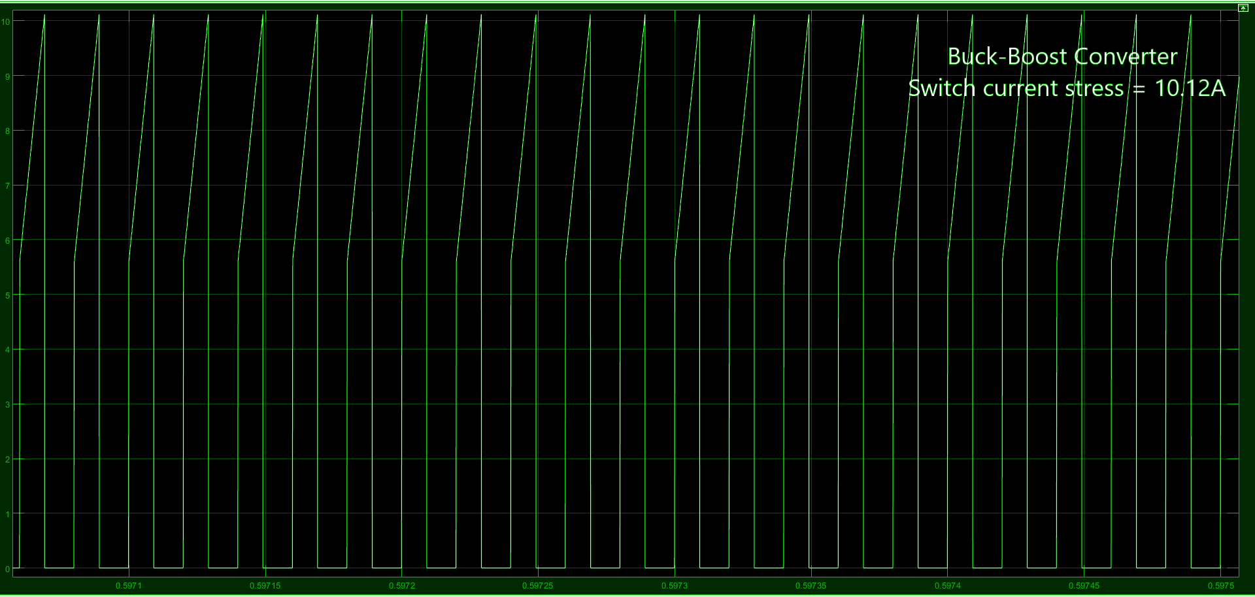

(d): Current stress of Diode. The boost converter has higher diode current stress

in a given working condition.

Boost converter

Diode current stress=19.03A

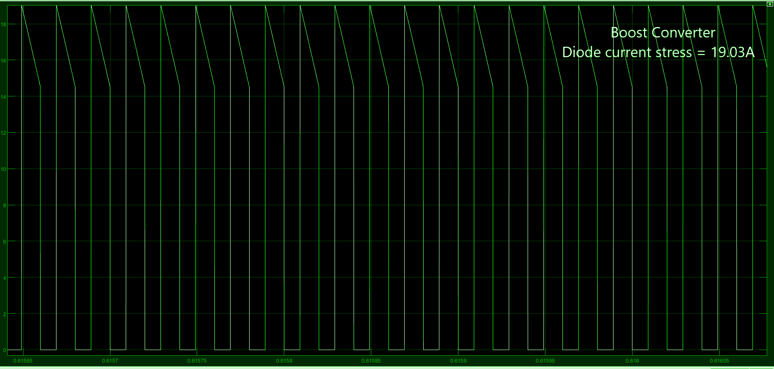

Buck-boost converter

Diode current stress=10.14A

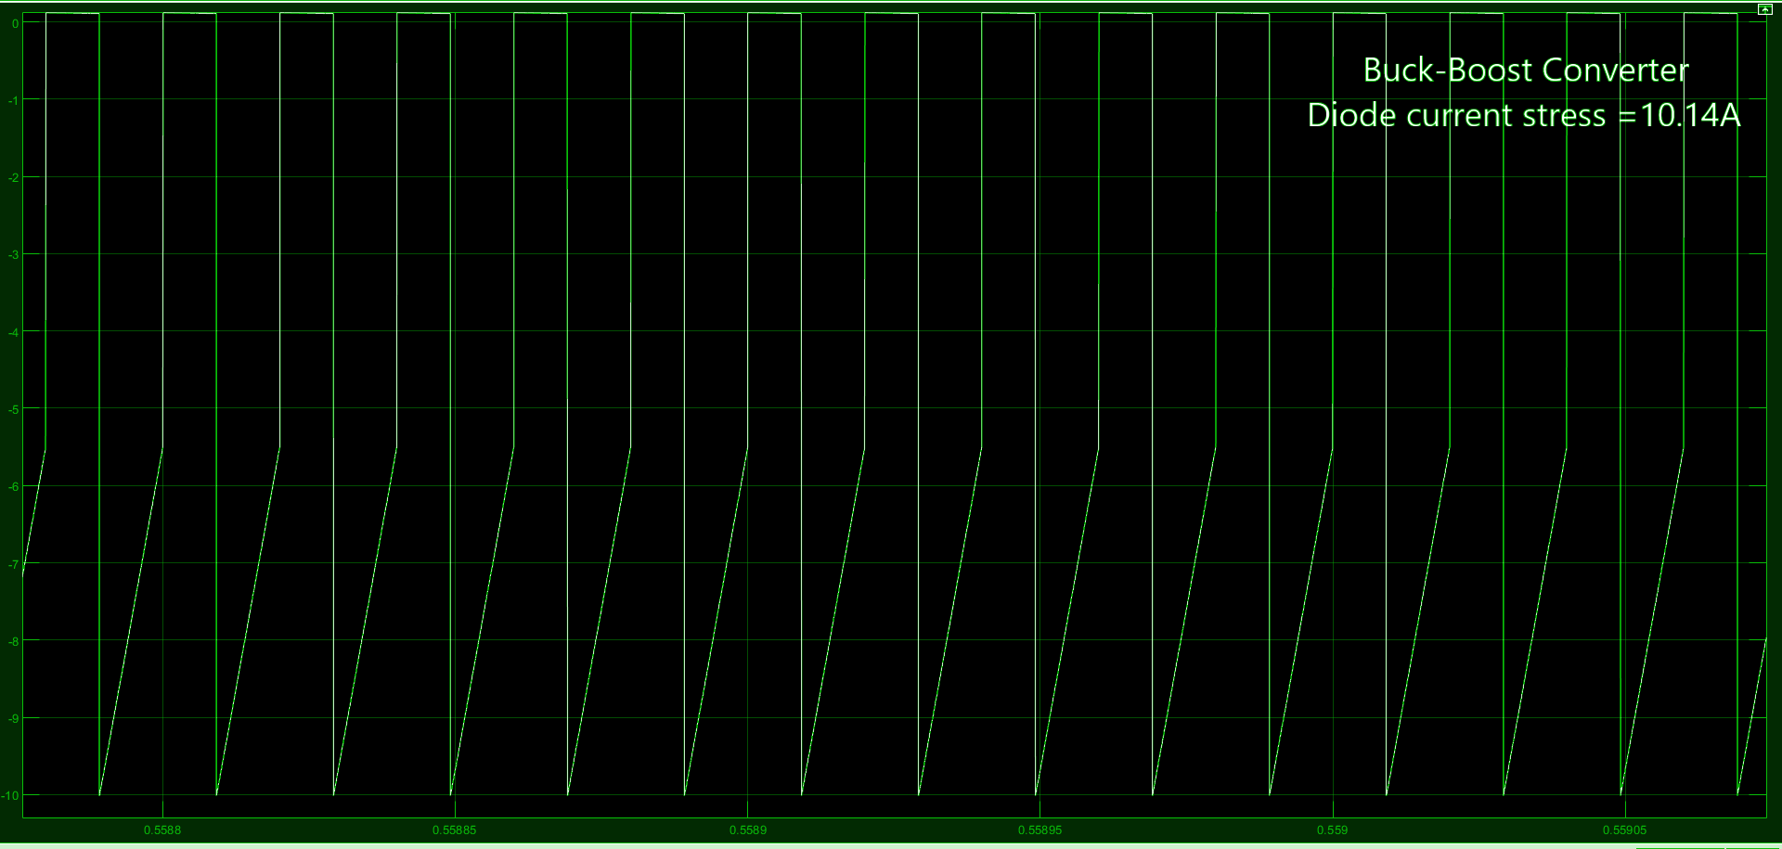

(e): Inductor current ripple. Both are almost the same.

Boost converter

Inductor current ripple=4.53A

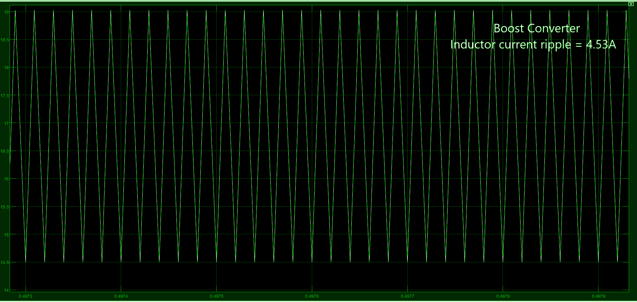

Buck-boost converter

Inductor current ripple=4.53A

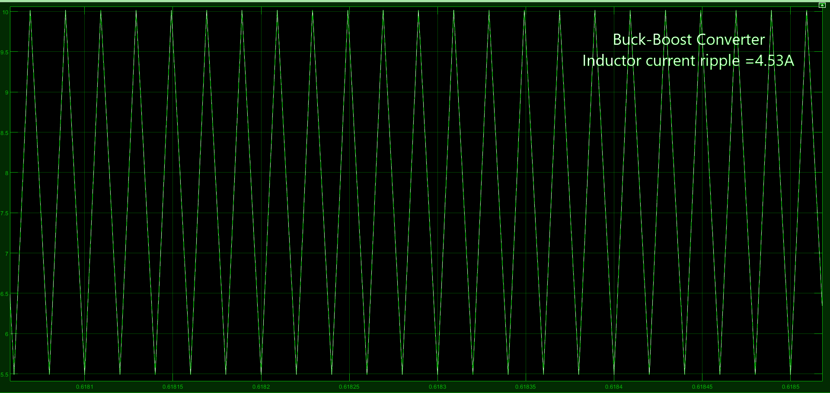

(f): Output voltage ripple. Ripple is more in Boost converter.

Boost converter

Output voltage ripple=1.66A

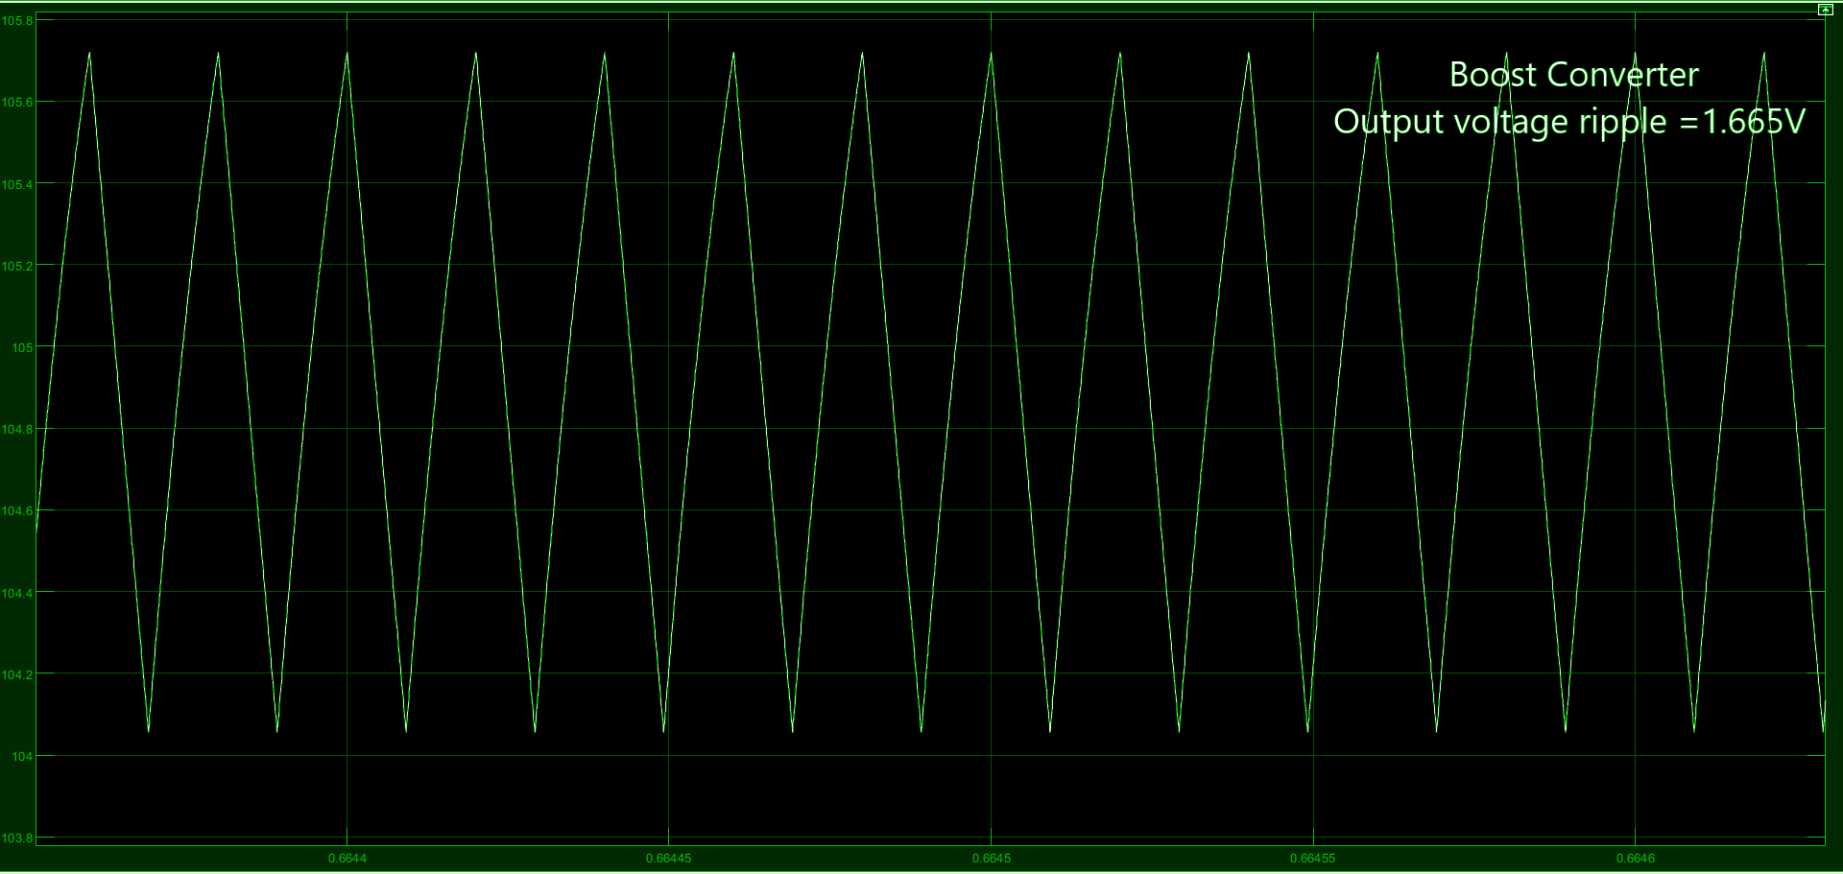

Buck-boost converter

Output voltage ripple=0.78A

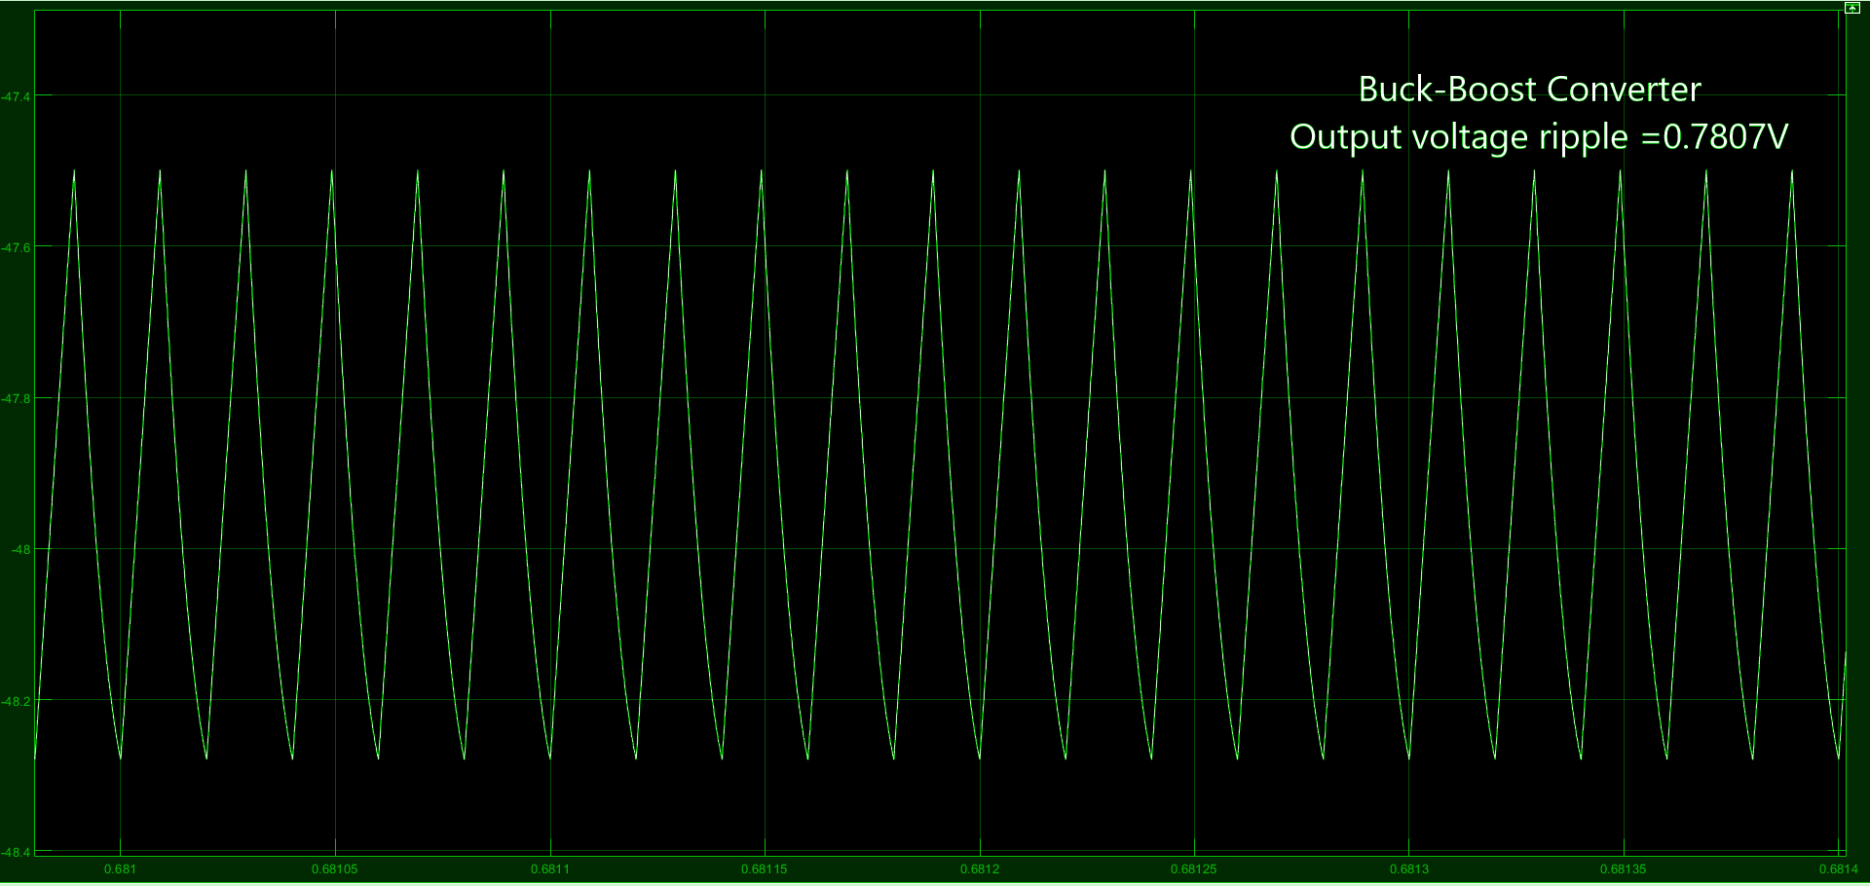

____________________________________________________________________________

DISCUSSION QUESTIONS :

1. Comment on the comparison of overall (both core and copper loss) loss of the inductor when the inductance is changed from specified value in CCM to critical inductance value. Assume inductor resistance has not changed.

Experiment shows that when the inductance is changed from a specified value in CCM to a critical inductance value, core loss increases but the copper loss remains constant. Finally, when a critical state is achieved then, overall loss increases even more.

2. Assuming ideal boost converter, compare the theoretical and simulated value of Vout for duty ratio=1, and write down your observations.

In theory, the output voltage of the ideal boost converter should go to infinity. But in the experiment at a duty ratio of 0.1, the output appears 0.

3. For a given duty ratio and load, voltage gain is higher in DCM or CCM? Why? (Consider ideal Boost Converter)

For an ideal boost converter, it is observed that the voltage gain under DCM is greater than the CCM condition. In CCM mode the inductor current is always positive. In DCM mode the inductor current goes to negative in one switching cycle. The gain in CCM mode is independent of load resistance. In CCM it does not reach 0 so at the end of every switching cycle, there is some energy left. In DCM, all the energy each cycle is used up, and the capacitor stores the extra energy giving higher output voltage.